# MS Office Excel (Project 1B)

Hey everyone – welcome back! In this next tutorial, I’m going to create more formulas. I continued to use the data for Pro Fit Marietta. But in this second half, I created more formulas. Josh Feingold is the company’s operations manager. He wants to know the retail value of inventory for Pro Fit Marietta’s plyometric training products. Just like my first tutorial, I can either start fresh with a new blank Excel workbook or I can use a template. So, I chose to use the template.

The first thing I did was calculate the total retail value. To calculate the total retail value, I multiplied the quantity by the retail price. In cell E4, I typed in the following formula: =B4*D4

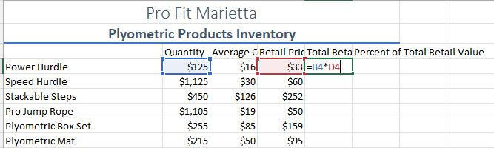

I used the fill down tool to drag and drop the formula vertically down to cell E9. While I still have the range selected, I clicked on the “Quick Analysis” icon and selected “Totals”. This let me calculate the total retail value for all products quicker than entering in a “SUM” formula. When I clicked on “Totals”, I had multiple options selected for our formulas. So, I selected “Sum” and formatted cell E10 with the “Total” cell style. Next, I formatted my values as “Currency” and got rid of the two spots after the decimal point.

The next piece of information I calculated was the percentage of total retail value. The percentage of retail value will be divided between the total retail value for each individual product by the total retail value for all products combined. Most of my formulas had the relative cell reference. When a formula with a relative cell reference is copied to another cell, the reference changes, based on the position of rows and columns. But with the percentage, this is where the absolute cell reference comes in. An absolute reference doesn't change, no matter where it’s copied. In cell F4, I typed in the following formula:

=E4/$E$10

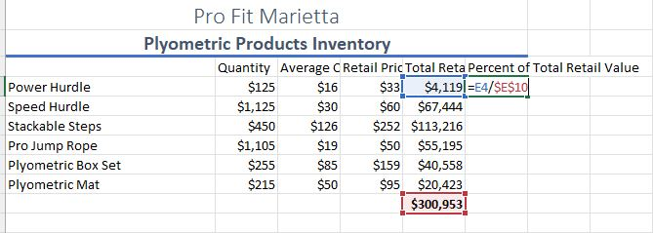

Since I didn't want the total retail value for all products to change in my formula, I added the dollar signs for cell E10. This kept cell E10 the same when I used the fill down tool to drag and drop the formula down vertically from cell E4 to E9.

One thing I can do in Excel is edit data and content. In cells B5 and D8, I changed the values from “1125” and “159.05” to “995” and “158.05”, respectively. When I changed the values in these two cells, my total in cell E10 also changed. In cell A2, I edited the subtitle of “Plyometric Products Inventory” and add the word “Valuation”. Then, we’ll add text in cell B3 to change the table heading from “Quantity” to “Quantity in Stock”.

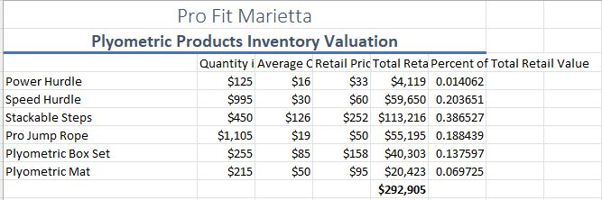

My spreadsheet is almost complete. But it would look more professional if I formatted it. First, I formatted my values in the Percent of Retail Value column as percentages rounded off to the nearest whole number. I highlighted the range from cells F4 to F9, navigated to the “Home” tab, went to the “Numbers” group, selected the percent sign and center aligned the values. Next, I highlighted row 3, right clicked, and chose “Insert”. This inserted a new row above row 3. I typed “As of September 30”. Just like my title and subtitle, I merged and centered the new text and applied the “Heading 2” cell style. Then, I selected column B, right clicked, and chose “Insert. In cell B4, I typed “Warehouse Location”. In cells B5, B6, and B10, I typed “Atlanta”. Cells B7, B8, and B9 will be “Marietta”. Next, I highlighted column D, right clicked, and selected “Delete” to get rid of the column. I highlighted columns B through F and set the width to 95 pixels. I selected the range from cells B4 to F4, navigated to the “Home” tab, went to the “Alignment” group, and selected “Wrap Text”. This will display the text on multiple lines. I clicked on “Center” and “Middle Align” to center align my text. Next, I applied the “Heading 4” cell style to my table headings. I typed in “Total Retail Value for All Products” in cell A11 and formatted the cell “40% - Accent 1”. I navigated to the “Page Layout” tab, went to the “Themes” group, click on “Colors”, and chose “Green”.

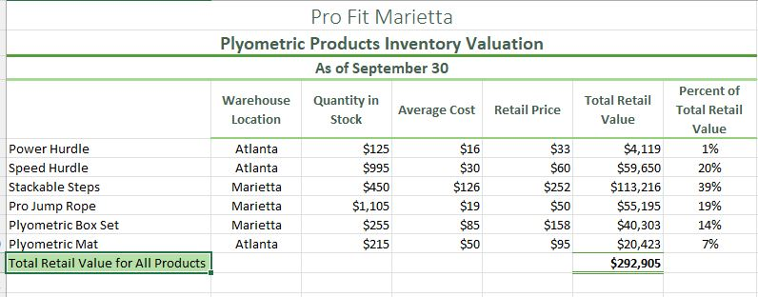

So, this is how we work with different operations and absolute cell references. Hope this tutorial was helpful, and I’ll see you in the next one!